PRODUCTDEMANDPREDICTIONWITH

MACHINELEARNINGS

**PHASE-3 Development Part-1**

## SUBMITTEDBY:

R.Umashankarau723921243051

[umaraji6383@gmail.com](mailto:umaraji6383@gmail.com)

Project: PRODUCTDEMANDPREDICTIONWITHMACHINE LEARNINGS

Phase-3**:**DevelopmentPart-1

Topic: Inthispartyouwi**l** beginbuildingyourprojectbyloadingand

preprocessing the dataset.

INTRODUCTION:

Predicting productdemandusingmachinelearninginvolves utilizing algorithms andhistoricaldata to forecast futuredemand foraspecific product. introductiontotheprocess: Data Collection and PreparationGatherhistorical datarelatedtotheproduct, including sales,customer demographics,seasonality, marketing efforts,and anyotherrelevantfactors. Cleanandpreprocessthis data toremoveerrors, outliers, orinconsistencies.Feature Engineering: Identifymeaningful featuresfromthedatathatcould impactproductdemand,suchaspricing,promotions, time of year, economicindicators, orcustomer behavior. These featureswill serveasinputsforthemachinelearning model. Model Selection:Chooseanappropriatemachinelearning modelbased ontheproblem,data, anddesiredpredictionaccuracy. Common models for demandpredictionincluderegressionmodels,time seriesmodels (e.g.,ARIMA, SARIMA), decisiontrees, random forests, andneuralnetworks.

Model Training:Train theselectedmodel using aportionofthe historicaldata. Themodellearnstorecognizepatternsand relationshipsbetween thechosenfeaturesandproduct demand.Model Evaluation: Assessthemodel'sperformance using validationdata. Common evaluationmetricsinclude Mean Absolute Error(MAE), Mean Squared Error(MSE), or R-squared, whichquantifytheaccuracyofpredictions.

Hyperparameter Tuning: Optimizethemodel'shyperparameters toenhanceitsperformance. Hyperparametersaresettingsthat influencethemodel'sbehaviourandcanbeadjustedtoimprove predictionaccuracy. Predictionand Forecasting Usethetrained andvalidatedmodel tomakepredictionsonfuturedata, projecting theproductdemandforspecifiedtimeperiods. These forecasts canguideinventorymanagement, production planning, and marketing strategies. Continuous Improvement: Periodically retrainandupdatethemodelwithnewdatatoensureitsrelevance andaccuracyinpredicting productdemandasmarketdynamics change

**GIVENDATASET :**

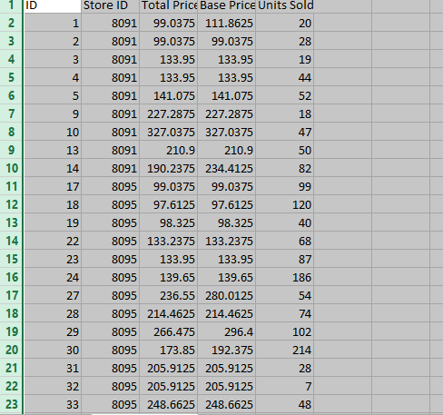

# Importance of Loading andpreprocessing datasets:

Loadingandpreprocessing datasetsarecrucialstepsinproduct demandpredictionwithmachinelearning.

# Data Integrity and Consistency:

Loading ensuresthedataisproperlyreadintothesystem, maintaining its integrityandconsistencyforaccurateanalysis.

# Data Understanding:

Preprocessing involvesexploring andunderstanding thedata, identifying missing values, outliers, andinconsistenciesthatmay impactpredictionmodels.

# Feature Engineering:

Preprocessing allowsfor feature extraction, transformation,and selection,enhancing thequalityandrelevanceoffeaturesfor predicting productdemand.

# Normalization and Scaling:

Preprocessing aidsinnormalizing andscaling features,ensuring uniformityandpreventing biastowardscertainfeaturesduring model training.

# Handling Missing Values:

Preprocessing addressesmissing data through imputationor removal,enabling effectiveutilizationofavailableinformation.

# Dealing with Categorical Data:

Conversionofcategoricalvariablestonumericalrepresentations facilitatestheirintegrationintomachinelearning models.

# Dimensionality Reduction:

Techniqueslike PCA orfeatureselectionhelp inreducingthe dataset'sdimensionswhileretaining essentialinformation, improvingmodel efficiency andperformance.

# Data Splitting:

Preprocessing often involvesdividingthedatasetintotraining, validation, andtestsets, ensuring anunbiasedevaluation of the model's performance.

loading andpreprocessing datasetspavethewayforcleaner, more meaningful data, ultimatelyenhancing theaccuracyand effectivenessof machinelearning models in

predicting product demand

## PythonProgram:

**importnumpy asnp importpandas aspd**

**importmatplotlib.pyplotasplt**

**importseaborn assns**

**data= pd.read_csv("Historical Product Demand.csv") data**

**data.head(10) data.tail(10) data.isna().sum()**

**data.dropna(axis =0,inplace=True)**

**data.isna().sum() data.describe(include='all')**

**data1 =pd.read_csv("PoductDemand.csv") data1**

**data1.mean()**

**data1.corr() sns.heatmap(data1.corr()) plt.show() plt.boxplot(data1)**

**data1.groupby('Units Sold').corr() fromsklearnimportpreprocessing sc=preprocessing.LabelEncoder()**

**fromsklearn.preprocessing import MinMaxScaler**

**le=MinMaxScaler() le.fit(x)**

**fromsklearn.model_selection importtrain_test_split**

**x_train,x_test, y_train,y_test= train_test_split(x,y,test_size = 0.25, random_state =50 )**

## ARCHITECTUREOFPRODUCTDEMANDPREDICTION:

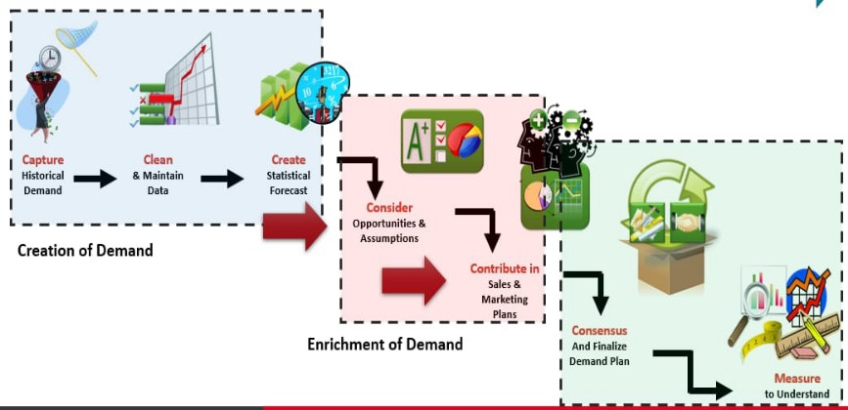

EXPLANATION:

**Product demand predictioninvolvesusing dataandstatisticaltechniques to forecast the future demand fora product.This prediction helpsbusinesses make informed decisionsregarding production, inventory,and marketing strategies.Several steps areinvolved in creating ademand prediction**

**modelDataCollection: Gatherhistorical sales data,customerpreferences, markettrends, economic indicators,andany otherrelevantdatasources.**

**Feature Engineering: Identifyand create relevantfeatures(variables) that could impact product demand,suchasprice, promotions, seasonality,or marketing activities.Model Selection: Choose asuitable predictive model, suchasregression,time seriesanalysis,machine learning algorithms (e.g., decisiontrees, neuralnetworks), or advanced forecasting techniques.**

**Training the Model: Usehistorical data totrainthechosenmodel, where the model learnsthe relationships betweenfeaturesand product demand.**

**Validation and Testing Assessthe model'sperformance usingvalidation datasets or techniques like cross-validationtoensure it accurately predicts demand.**

**ParameterTuning: Optimize the model by adjusting parameterstoachieve thebest predictive performance.Forecasting: Applythe trained and validated model tofuturedatatogenerate predictionsfor product demand. Evaluation: Evaluate the model'spredictive accuracyusing metricslike MeanAbsolute Error(MAE),Root Mean Squared Error(RMSE),orothers suitablefor thespecificproblem.Implementationand Monitoring: Implementthe model inthe businessoperationsand continuallymonitorand updatethemodel toadapttochanging marketdynamics. Byaccurately predicting productdemand, businesses can optimize theirsupplychains, manage inventoryefficiently,planmarketing campaignseffectively,and ultimatelyimprove theiroverall business strategy.**

**CONCLUSION:**

Conclusionleveragingmachinelearningforproductdemand predictionofferssignificantpotentialforbusinesses.By

analyzinghistoricaldataandutilizingadvancedalgorithms,

accuratedemandforecastscanbegenerated, aidingininformed decision-making, optimizedinventorymanagement, and enhancedcustomersatisfaction.However,it'scrucialto

continua**l** yrefineandupdatemodels, incorporatenewdata

sources,andconsidermarket

dynamicstoensurethepredictionsremainreliableandeffective inadynamicbusiness environment.